|  |  |
| --- | --- |
| **WDM** | **DWDM** |
|  |  |

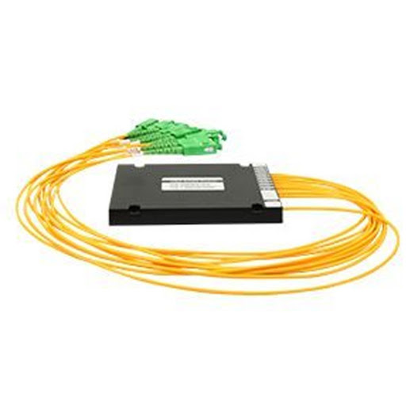

**FEATU**

**FFEATURES**

* Thin Film Filter Technology (TFF)
* Low insertion loss
* Low Polarization Dependent Loss
* High Channel Isolation
* High Stability & Reliability

**APPLICATIONS**

* DWDM Network
* CATV Optical Fiber Systems
* Fiber Optical Amplifier
* Data upload and download service

  **PERFORMANCE SECTION**

|  |  |  |  |  |  |  |  |  |
| --- | --- | --- | --- | --- | --- | --- | --- | --- |
| **Parameter** | | **Unit** |  |  | **Value** | | | |
| Center Wavelength | | nm |  |  | ITU Grid | | | |
| Product Type | | - |  | Mux、Demux or Mux&Demux | | | | |
| Channel Spacing | | GHz |  | 100G | |  |  | 200G |
| 0.5dB Bandwidth | | nm |  | ＞0.3 | |  |  | ＞0.5 |
| Channel Number | | ch | 4 |  | 8 | |  | 16 |
| Insertion Loss | | dB | ≤1.8 |  | ≤3.0 | |  | ≤5.0 |
| Channel Ripple | | dB |  |  | ≤0.5 | |  |  |
| Isolation | Adjacent | dB |  |  | ＞30 | | | |
| Non- | dB |  |  | ＞45 | | | |
|  | Adjacent |  |  |
|  |  |  |  |  |  |  |  |
| Directivity | | dB |  |  | ≥50 | |  |  |
| Return Loss | | dB |  |  | ≥45 | |  |  |
| Polarization Dependent | | dB |  |  | ＜0.2 | | | |
| Loss | |  |  |
|  |  |  |  |  |  |  |
| Polarization Mode | | ps |  |  | ＜0.1 | | | |
| Dispersion | |  |  |
|  |  |  |  |  |  |  |
| Insertion Loss | | dB/℃ |  |  | ＜0.005 | | | |
| Temperature Sensitivity | |  |  |
|  |  |  |  |  |  |  |
| Wavelength Temperature | | nm/℃ |  |  | ＜0.002 | | | |
| Sensitivity | |  |  |
|  |  |  |  |  |  |  |
| Connector | |  |  | LC/PC、SC/PC or Specified | | | | |
| Other Ports | | - |  |  | As Specified | | | |
| Operation Temperature | | ℃ |  |  | -5～+70 | | | |
| Storage Temperature | | ℃ |  |  | -40～+85 | | | |
| Package | | - |  | LGX、Box、Rack or specified | | | | |
|  |  |  | Box Type ：100×80×10 or 120×80×18 | | | | | |
| Package Dimensions | | mm | LGX：201×256×44 or 155×100×29 | | | | | |
|  |  |  | Rack Mounted：482×260×44 or | | | | 2U：482×260×88 | |

|  |  |  |  |  |  |  |  |  |  |
| --- | --- | --- | --- | --- | --- | --- | --- | --- | --- |
| **Product** | **Channe** | **Functi** | **Chann** | **1st** | **Packag** | **Termin** | **Connect** | **Fiber** | **Input/Outp** |
| **el** | **Chann** |
| **Series** | **l Space** | **on** | **e** | **al** | **or** | **Type** | **ut Length** |
| **Numbe** | **el** |
|  |  |  |  |  |  |  |  |
|  |  |  | **r** |  |  |  |  |  |  |
| D=DWD | 05=50G | D=Dem | 08= 08 | C21 |  | A=Adapt | LC/UPC | 0.9A=0.9 |  |
| C22 | B=Box | mm | 05/05= 1m |
| M | Hz | ux | CH | er | LC/APC |
| C23 |  | G657A2 |  |
|  |  |  |  |  |  |  |  |
| OD=OA | 1=100G |  | 16= 16 | L70 | P=Cass | F=Conne | SC/UPC | 2.0A1=2. |  |
| DM | M=Mux | 0mm | 10/10=1m |
| Hz | CH | L71 | ette | ctor | SC/APC |
| DWDM |  | G657A1 |  |
|  |  |  |  |  |  |  |  |
|  | 2=200G | D&M= | 12= 12 |  | R=Rac | N=No | FC/UPC | Rb= |  |
|  | Demux | ……. | connecto | Bare | 20/20= 2m |
|  | Hz | CH | k | FC/APC |
|  | & Mux |  | r | fiber type |  |
|  |  |  |  |  |  |  |